|  |  |  |  |  |
| --- | --- | --- | --- | --- |
| Medic-kIt | | | | |
|  |  | | |  |
| stay FIT, ANYWHERE, everywhere | | | | |
|  | |  |  | |

|  |  |  |
| --- | --- | --- |
| **Sr. No.** | **TABLE OF CONTENTS** | **Page No.** |
| **1.** | **INTRODUCTION** |  |
|  | 1.1 Existing System | 4 |
|  | 1.2 Need for the New System | 5 |
|  | 1.3 Objective of the New System | 6 |
|  | 1.4 Problem Definition | 7 |
|  | 1.5 Core Components | 8 |
|  | 1.6 Project Profile | 9 |
|  | 1.7 Assumptions and Constraints | 10 |
|  | 1.8 Advantages and Limitations of the Proposed System | 11 |
| **2.** | **REQUIREMENT DETERMINATION & ANALYSIS** |  |
|  | 2.1 Requirement Determination | 12 |
|  | 2.2 Targeted Users | 13 |
| **3.** | **SYSTEM DESIGN** |  |
|  | 3.1 Use Case Diagram | 14 |
|  | 3.2 Data Dictionary | 17 |
| **4.** | **DEVELOPMENT** |  |
|  | 4.2 Screenshots | 28 |
| **5.** | **AGILE DOCUMENTATION** |  |
|  | 5.1 Agile Project Charter | 48 |
|  | 5.2 Agile Project Plan | 49 |
| **6.** | **CONCLUSION** | 52 |
| **7.** | **BIBLIOGRAPHY** | 53 |

# Introduction

Creating a system where a user can have a one-stop solution to all their medical needs, be it knowing what illness they have, review consulting with doctor, viewing medicines, booking appointments and many more.

The overall website plan according to the business plan lies in:

* Consulting doctors on a chatting-platform built in the system.
* Facial recognition login
* Purchasing medicines
* Calory count
* And many more

It is recommended to read the entire document to understand the basic and the advanced understanding of the system. The information is with the view point of development of the website for “medic-kit”.

It is important to keep the business plan updated in order to see progress, celebrate success, and adjust where issues arise. This is best done on a quarterly, if not monthly, basis.

# 1.1 Existing system

PharmEasy offers medicines and health products across various categories through its retail partners which are spread across the country. You can simply place an order on our website and we will deliver your online medicine order with a guaranteed period of time.

Microsoft To Do is the task management app that makes it easy to stay organized and manage your life. Accomplish what’s important to you each day with Suggestions, personalized day planner tools. Intelligent suggestions recommend tasks from across your lists that may be relevant each day.

**Real Time telemedicine** allows patients and healthcare providers to remotely assess patients in real time through video and telephonic services, whereby physicians can take medical history and provide appropriate medical advice.

# 1.2 NEED for the new system

There are systems already available in the market, which contain all the basic medical-problem solution, but here are the problems that a user face:

* Lack of knowledge on the best website or service to use for his specific needs.
* Online access to trusted physicians or medications is difficult.
* No in-house calorie counter; if there is one, the price is exorbitant.

The new approach, "Medic-Kit," is a one-step answer to every problem a Google searcher looks for differently for different medical difficulties, such as "what may I have" followed by symptoms or "the finest doctor for [illness] in [place]."

User now a days using notepad to save the notes but it has to be saved somewhere and many time user forget where it stored and to answer to that problem To-do list is introduced which stores notes in user account itself that helps them to find and store it more easily

A single website which provides your BMI based on your body, along with the average BMI of people from your age group, where you can manage your calorie intake along with keeping track of what you have to and do not have to do

Patients now a days have to book appointment with doctors for their concerns but sometime it clashed the timing with other patients and answer to that problem is our system arranged the section of appointment that schedule the doctor and let them help to know their free slots

Now a days buying advance medicine is a headache because of lack of availability. Sometimes users have to search in multiple stores which cost him lot of stress and money

Our system helps them to get it at their door step

# objective of the new system

To provide the one step solution to the medical needs, a user can Make a reservation and can also Monitor and record their caloric intake along with Discussing issues with medical professionals for Buying prescription drugs, and one can also make a list of tasks to complete, such as keeping a fitness journal, among other things**.**

# 1.4 Problem Definition

Providing one step solution to users looking for ideal hospitals, doctors, medicines and scope of the disease to the problems they are facing.

# 1.5 core components

The core components for the “Medic-kit” project include:

* Login
* Registration
* Face-recognition login
* To-do list
* Display Symptoms->diseases
* Tweet/Update your own timeline
* Mail users
* Chat interface
* Blog/news update
* Hospital/doctor suggestion according to disease/problem
* Ideal profile display (based on personal data, calculated using BMI)
* Calory counter
* Treatment/remedy
* Prescription list
* Appointment taking
* Request meds
* Update Profile
* Change Password
* Contact us
* Feedback
* admin: manage doctors
* admin: manage patients
* admin: manage diseases/problems
* admin: manage symptoms
* view hospital/doctor information
* view medical history
* add medical history

# project profile

|  |  |
| --- | --- |
| Project title | Medic-Kit |
| Project Description | Creating a system where a user can have a one-stop solution to all their medical needs. |
| Project Team | Kenil Thakkar, Janhvi Agarwal, Varad Joshi |
| Front-End and Back-End | Django 4.1, CSS5, HTML5, JS |
| Database | MySQL |
| Evaluators | Mr. Neeraj Gautam,  Mr. Himanshu Sharma |

# assumptions and constraints

Here are a few constraints and assumptions for the system:

Assumptions

* Users will use for knowing their diseases
* User can buy drugs as per their requirements

Constraints:

* User have to wait for the confirmation for doctor reservation
* Limited contacts with local stores and doctors

# Advantages and Limitations of the Proposed System

Advantages:

* Single stop solution
* Simple navigation
* Recommended medical professionals
* Optimal medication as recommended
* Eases 50-60% of user task while sitting at home
* Quick scheduling of appointments

Limitations:

* Less contact with doctors and medical stores: gradual improvement
* Limited contacts with local stores and doctors

# requirement determination and analysis

# requirement deteremination

After well-done research, we came up with the conclusion that there is no perfect system for a user, who wants to have his calory management, knowing which possible disease is associated with his symptoms, talking to doctors or viewing best hospitals, or even manage his to-do list for heath checks!

Medic-kit provides that platform to every google searcher who gets scared to “what if my cough turns out to be cancer” and many more day-to day problems.

# targated users

Targeted users for the system include:

* Patients
* Doctors
* Pharmacist

# SYstem design

# Use case Digarm

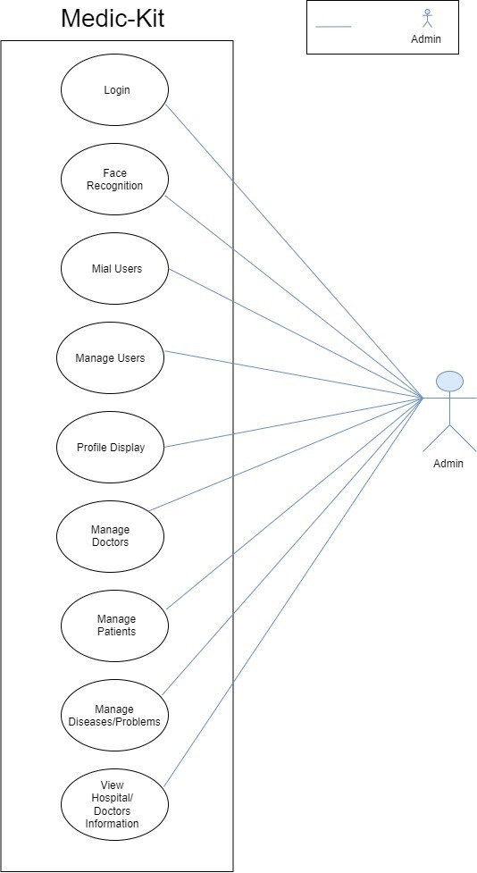

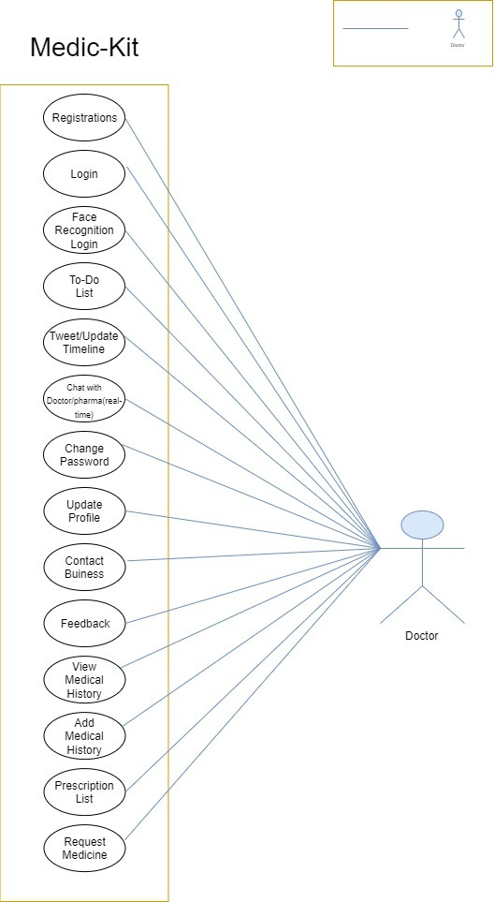

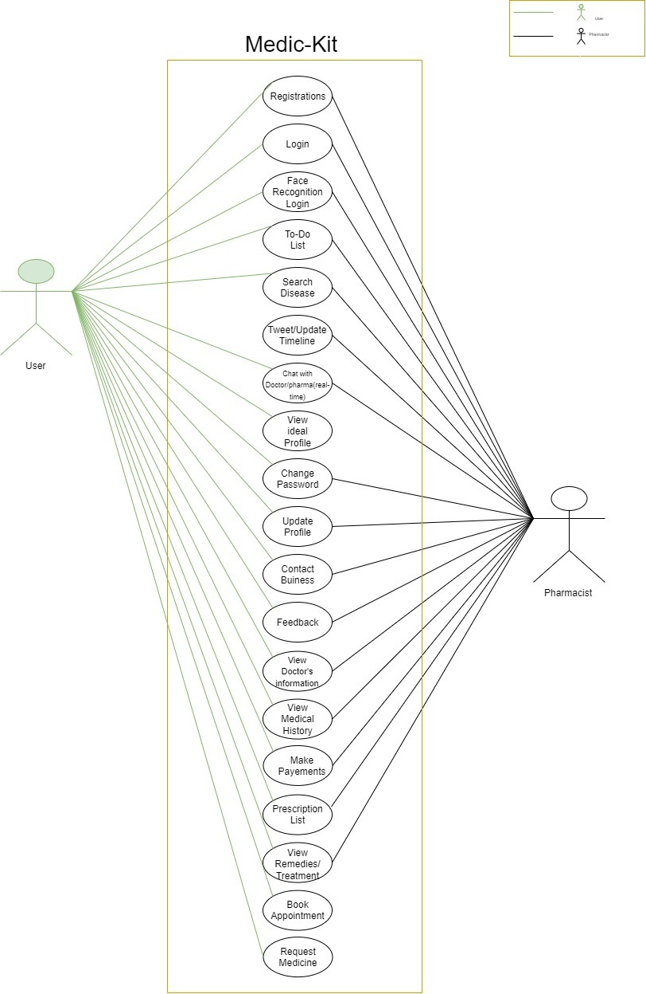

# dATA DICTIONARY

USER TABLE:

|  |  |  |  |  |  |
| --- | --- | --- | --- | --- | --- |
| Field Name | Data Type | Length of Field | Primary/Foreign Key | Constraints | Description |
| Id | BigIntergerField | 20 | Primary | Not null, auto-increment | ID of each user |
| First_name | CharField | 100 | - | Not-null | User first name |
| Last_name | CharField | 100 | - | Not-null | User last name |
| username | CharField | 100 | - | Not-null | User’s username of choice |
| Email | EmailField | - | - | Not-null | User’s email id |
| address | CharField | 256 | - | Not-null | User’s address |
| password1 | CharField | 256 | - | Not-null | User’s password |
| Image | ImageField | - | - | Not-null | User’s image for face recognition |

DOCTOR TABLE:

|  |  |  |  |  |  |
| --- | --- | --- | --- | --- | --- |
| Field Name | Data Type | Length of Field | Primary  /Foreign Key | Constraints | Description |
| Id | BigIntergerField | 20 | Primary | Not null, auto-increment | ID of each doctor |
| Name | CharField | 100 | - | Not-null | Doctor’s name |
| age | IntegerField | - | - | Not-null | Doctor’s age |
| experience | IntegerField | - | - | Not-null | Doctor years of experience |
| phone | IntegerField | - | - | Not-null | doctor phone number |
| hosName | CharField | 100 | - | Not-null | Doctor’s hospital or clinic name |
| hosLocation | CharField | 256 | - | Not-null | Doctor’s hospital or clinic address |
| username | CharField | 100 | - | Not-null | Doctor’s username |
| Email | EmailField | - | - | Not-null | Doctor’s email |
| degree | CharField | 256 | - | Not-null | Doctor’s specification degree |
| password | CharField | 256 | - | Not-null | Doctor’s password |
| Image | ImageField | - | - | Not-null | User’s image for face recognition |

PHARMACIST TABLE:

|  |  |  |  |  |  |
| --- | --- | --- | --- | --- | --- |
| Field Name | Data Type | Length of Field | Primary/Foreign Key | Constraints | Description |
| Id | BigIntergerField | 20 | Primary | Not null, auto-increment | ID for each pharmacist |
| name | CharField | 100 | - | Not-null | Pharmacist’s name |
| shopName | CharField | 100 | - | Not-null | Pharmacist’s Shop name |
| shopAddr | CharField | 256 | - | Not-null | Pharmacist’s shop address |
| licenseNumber | IntegerField | - | - | Not-null | Pharmacist’s medicine selling license number |
| username | CharField | 100 | - | Not-null | Pharmacist’s username |
| email | EmailField | - | - | Not-null | Pharmacist’s email |
| NationwideDel | BooleanField | - | - | Not-null | If delivers nationwide |
| city | CharField | 256 | - | Not-null | Pharmacist’s shop city location |
| password | CharField | 256 | - | Not-null | Pharmacist’s password |
| Image | ImageField | - | - | Not-null | User’s image for face recognition |

CONTACT US:

|  |  |  |  |  |  |
| --- | --- | --- | --- | --- | --- |
| Field Name | Data Type | Length of Field | Primary/Foreign Key | Constraints | Description |
| Id | BigIntergerField | 20 | Primary | Not null, auto-increment | ID for each contact |
| name | CharField | 100 | - | Not-null | Contactor’s name |
| Email | EmailField | - | - | Not-null | Contactor’s email |
| Subject | CharField | 300 | - | Not-null | Subject of contact |
| Message | CharField | 256 | - | Not-null | Contact message |

FEEDBACK:

|  |  |  |  |  |  |
| --- | --- | --- | --- | --- | --- |
| Field Name | Data Type | Length of Field | Primary/Foreign Key | Constraints | Description |
| Id | BigIntergerField | 20 | Primary | Not null, auto-increment | ID for each feedback |
| Rating | IntegerField | - | - | Not-null | Usage rating |
| Message | CharField | 256 | - | Null | Feedback message |

ILLNESS:

|  |  |  |  |  |  |
| --- | --- | --- | --- | --- | --- |
| Field Name | Data Type | Length of Field | Primary/Foreign Key | Constraints | Description |
| Id | BigIntergerField | 20 | Primary | Not null, auto-increment | ID for each disease |
| Disease | CharField | 100 | - | Not-null | Disease name |
| Symptom_1 | CharField | 300 | - | Not-null | Disease major symptom #1 |
| Symptom_2 | CharField | 300 | - | Not-null | Disease major symptom #2 |
| Symptom_3 | CharField | 300 | - | Not-null | Disease major symptom #3 |

TO-DO LIST:

|  |  |  |  |  |  |
| --- | --- | --- | --- | --- | --- |
| Field Name | Data Type | Length of Field | Primary/Foreign Key | Constraints | Description |
| Id | BigIntergerField | 20 | Primary | Not null, auto-increment | ID for each feedback |
| Task | CharField | 300 | - | Not-null | User Task #1 |
| Username | CharField | 256 | Foreign | Not-null | User’s username |
| Type | IntegerField | 256 | - | Not-null | Type of user |

TO-DO ITEMS:

|  |  |  |  |  |  |
| --- | --- | --- | --- | --- | --- |
| Field Name | Data Type | Length of Field | Primary/Foreign Key | Constraints | Description |
| Id | BigIntergerField | 20 | Primary | Not null, auto-increment | ID for each to-do-item |
| Ttile | CharField | 100 | - | Not-null | Title of the item |
| Description | TextField | 256 | - | Not-null | Description of the item |
| Created_date | DatetimeField | - | - | Not-null | Date of item creation |
| Due_date | DatetimeField | - | - | Not-null | Due date of task |
| Todo_list | CharField | 100 | Foreign | Not-null | To do list associated with item |

TIMELINE:

|  |  |  |  |  |  |
| --- | --- | --- | --- | --- | --- |
| Field Name | Data Type | Length of Field | Primary/Foreign Key | Constraints | Description |
| Id | BigIntergerField | 20 | Primary | Not null, auto-increment | ID for each feedback |
| User Id | IntegerField | - | Foreign | Not-null | User’s ID |
| Timeline | CharField | 300 | - | Not-null | Timeline update #1 |
| Type | IntegerField | - | - | Not-null | Type of user |

CHAT INTERFACE:

|  |  |  |  |  |  |
| --- | --- | --- | --- | --- | --- |
| Field Name | Data Type | Length of Field | Primary/Foreign Key | Constraints | Description |
| Id | BigIntergerField | 20 | Primary | Not null, auto-increment | ID for each feedback |
| SenderId | CharField | 256 | Foreign | Not-null | User sender username |
| ReceiverId | CharField | 256 | Foreign | Not-null | User receiver username |
| message | CharField | 300 | - | Not-null | Chat message |
| Date | DateField | - | - | Not-null | Chat date |

CALORIE-MANAGEMENT:

|  |  |  |  |  |  |
| --- | --- | --- | --- | --- | --- |
| Field Name | Data Type | Length of Field | Primary/Foreign Key | Constraints | Description |
| Id | BigIntergerField | 20 | Primary | Not null, auto-increment | ID for each ideal calory data |
| Patient ID | IntegerField | - | Foreign | Not-null | Patient’s ID |
| age | IntegerField | - | - | Not-null | Patient’s age |
| Ideal_bmi | FloatField | - | - | Not-null | Ideal BMI for that age |
| Ideal_height | FloatField | - | - | Not-null | Ideal height for that age |
| Ideal_weight | FloatField | - | - | Not-null | Ideal weight for that age |
| Idela_calorie_intake | FloatField | - | - | Not-null | Ideal calory intake for that age |
| Your_weight | FloatField | - | - | Not-null | Patient’s weight |
| Your_height | FloatField | - | - | Not-null | Patient’s height |
| Your_bmi | FloatField | - | - | Not-null | Patient’s BMI |
| Calorie_to_intake | FloatField | - | - | Not-null | Calories to be consumed by the user |

MEDICAL HISTORY:

|  |  |  |  |  |  |
| --- | --- | --- | --- | --- | --- |
| Field Name | Data Type | Length of Field | Primary/Foreign Key | Constraints | Description |
| Id | BigIntergerField | 20 | Primary | Not null, auto-increment | ID for each patient-history |
| Patient_id | integerField | - | Foreign | Not-null | Patient ID |
| Doctor_id | integerField | - | Foreign | Not-null | Doctor ID |
| Date | DateField | - | - | Not-null | Date of approach |
| Problems | CharField | 256 | - | Not-null | Patient’s suffering from which problems |
| Prescription | CharField | 300 | - | Not-null | Prescription to solve the problems |

APPOINTMENT:

|  |  |  |  |  |  |
| --- | --- | --- | --- | --- | --- |
| Field Name | Data Type | Length of Field | Primary/Foreign Key | Constraints | Description |
| Id | BigIntergerField | 20 | Primary | Not null, auto-increment | ID for each appointment |
| Fname | CharField | 256 | - | Not-null | Patients name |
| lname | CharField | 256 | - | Not-null | Patients name |
| Email | EmailField | - | - | Not-null | Patient’s email |
| Time | CharField | 256 | - | Not-null | Appointemtn time |
| Day | CharField | 256 | - | Not-null | Appointment time |
| Request | CharField | 256 | - | Not-null | Appointment request |
| Patient_id | integerField | - | Foreign | Not-null | Patient ID |
| DoctorId | IntegerField | - | Foreign | Not-null | Doctor’s ID |
| Status | IntegerField | - | - | Not-null | Appointment status |

MEDICINES:

|  |  |  |  |  |  |
| --- | --- | --- | --- | --- | --- |
| Field Name | Data Type | Length of Field | Primary/Foreign Key | Constraints | Description |
| Id | BigIntergerField | 20 | Primary | Not null, auto-increment | ID for each appointment |
| Pharma_id | integerField | - | Foreign | Not-null | Pharmacist ID |
| Pharma_name | CharField | 100 | Foreign | Not-null | Pharmacist name |
| MedicineName | CharField | 100 | - | Not-null | Medicine name |
| DateOfExpiry | DateField | - | - | Not-null | Medicine’s date of expiry |
| MedicinePrice | FloatField | - | - | Not-null | Medicine Price |
| MedicineUse | CharField | 256 | - | Not-null | Medicine used for |

# development

# 4.1 Screenshots

1)Registration

A) User

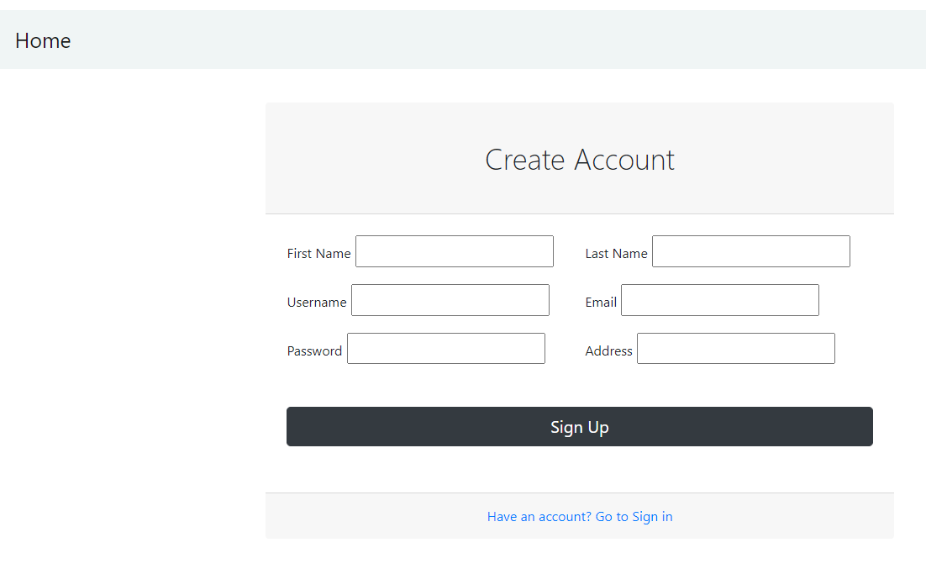

B) Doctor

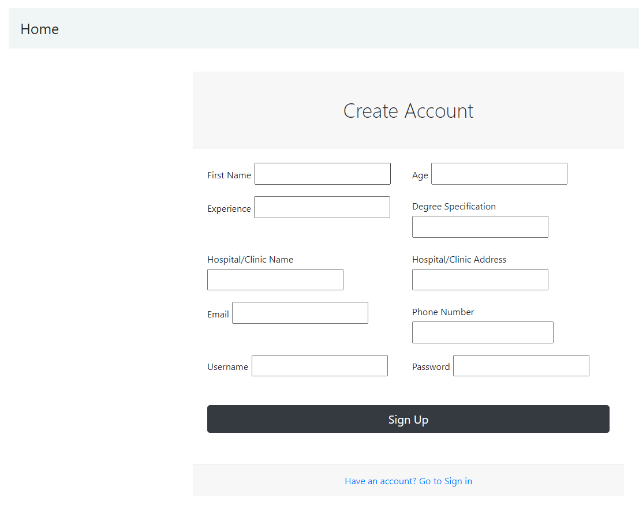

C)Pharmacist

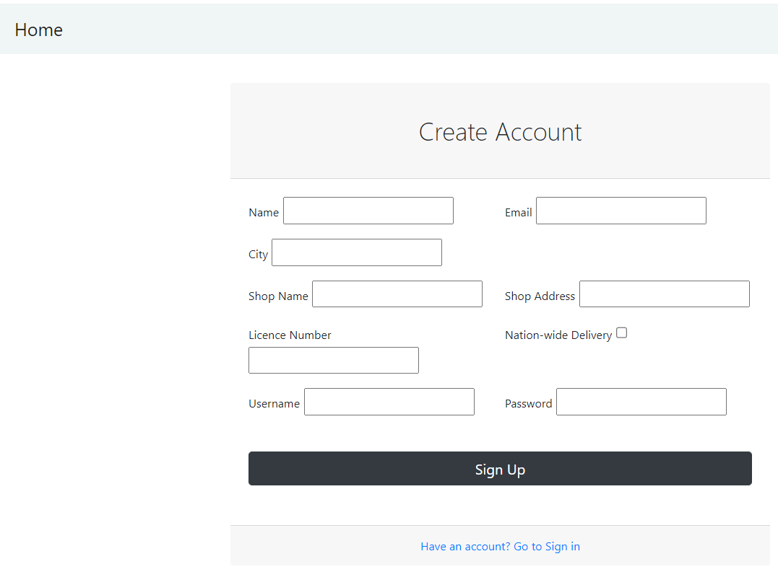

2)Login

A) User

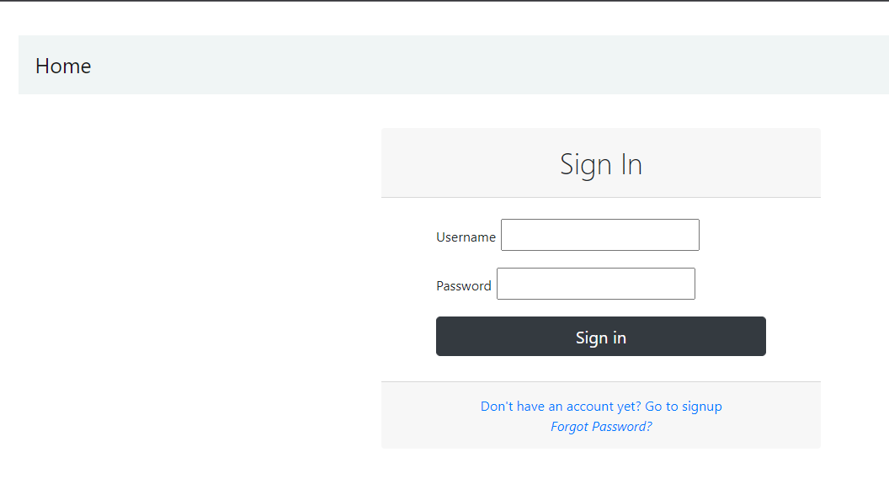

A) Doctor



A) Pharmacist



3) User Side

A) Home

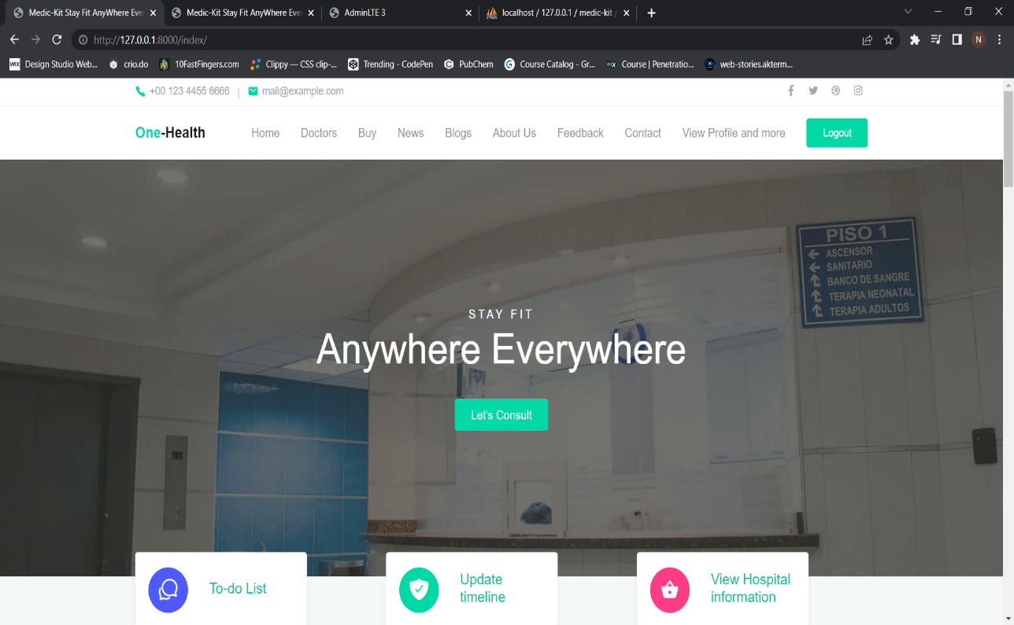

B) View Doctor

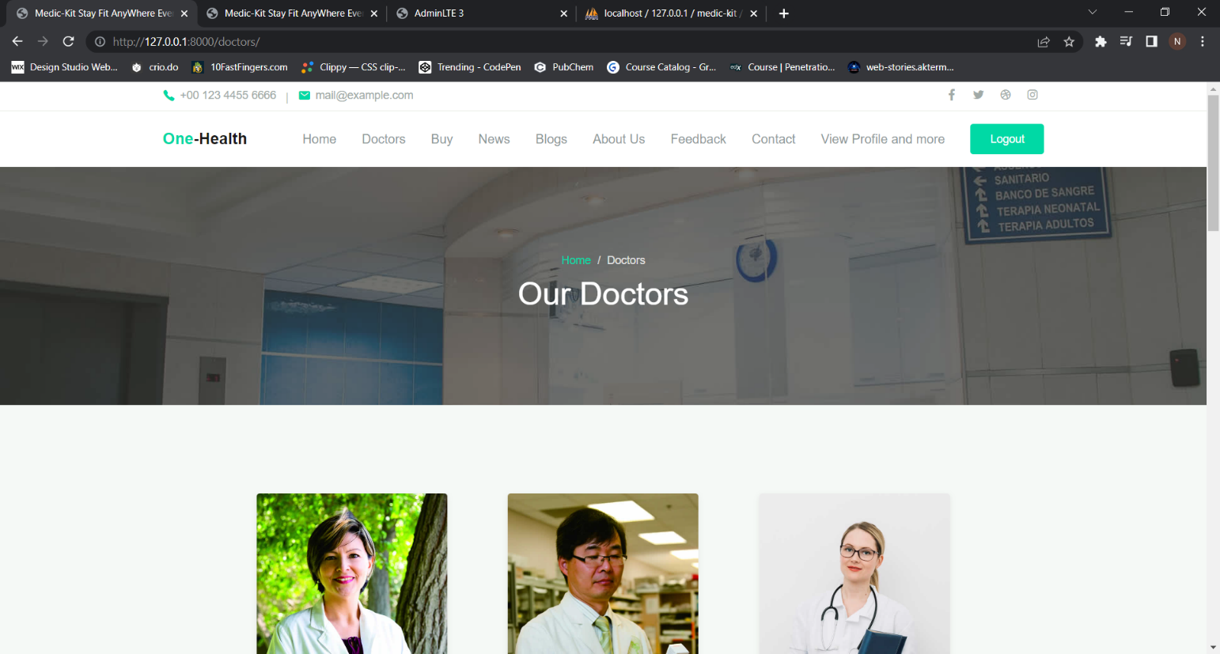

C) Buy Medicine

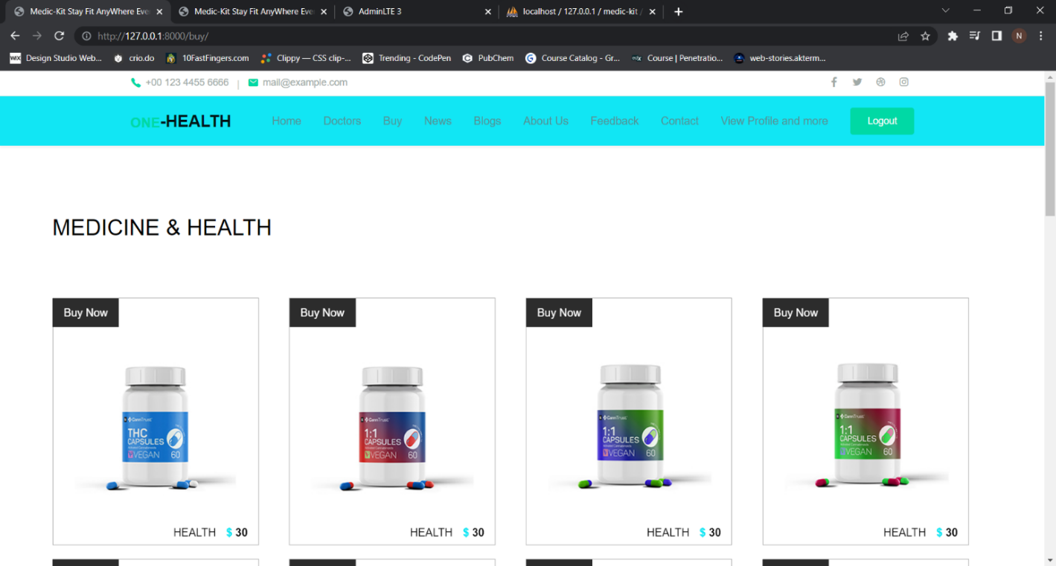

D) View News

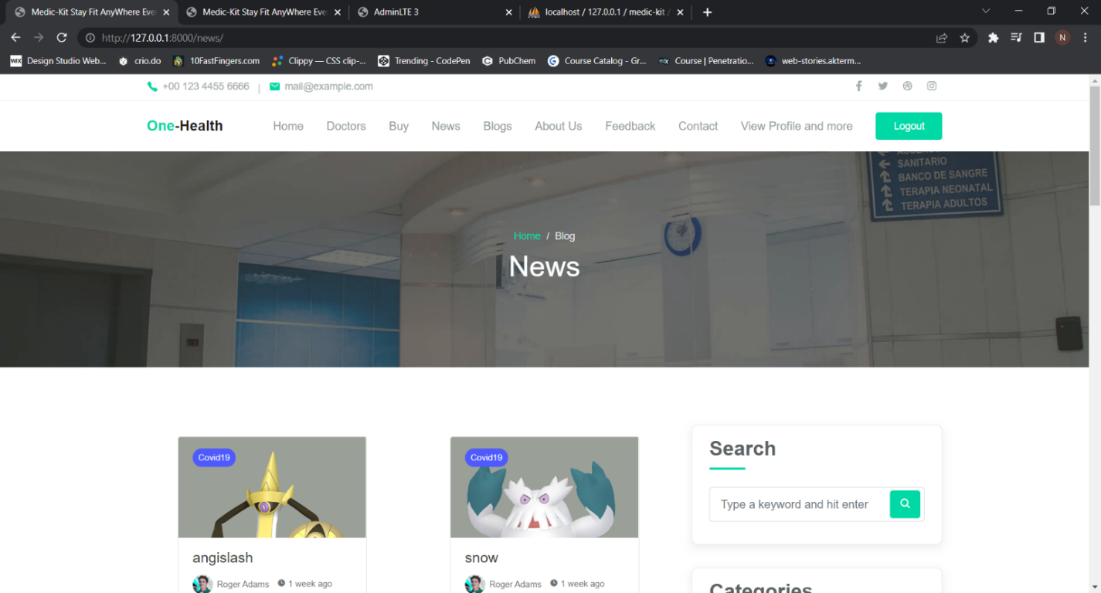

E) View Blogs

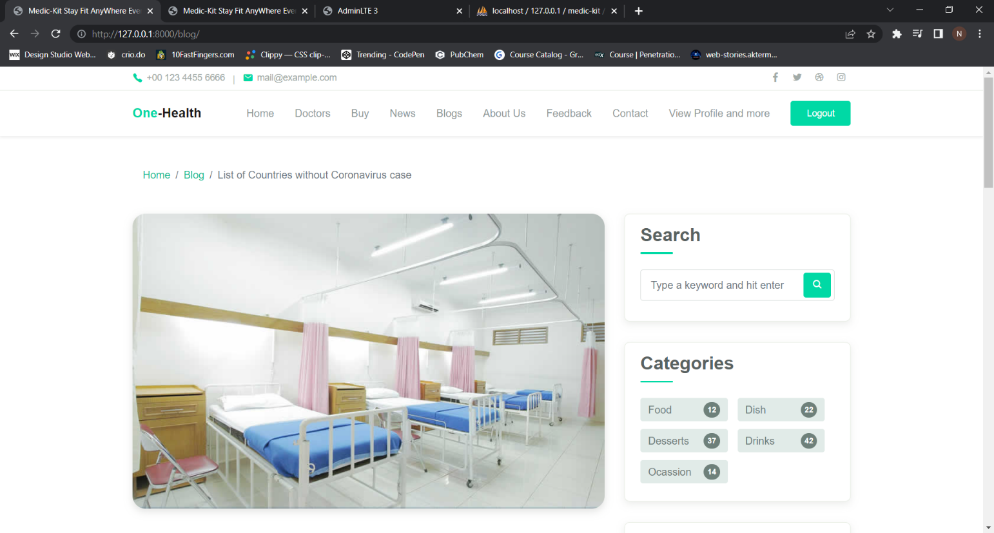

F) About Us

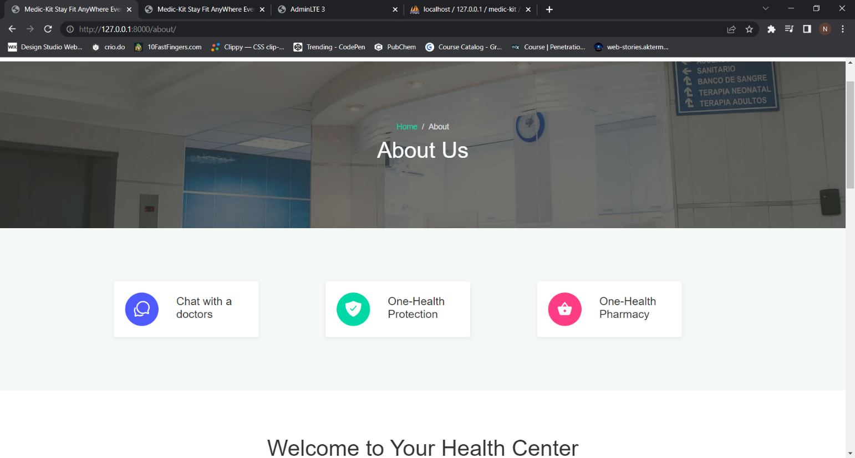

G) Profile

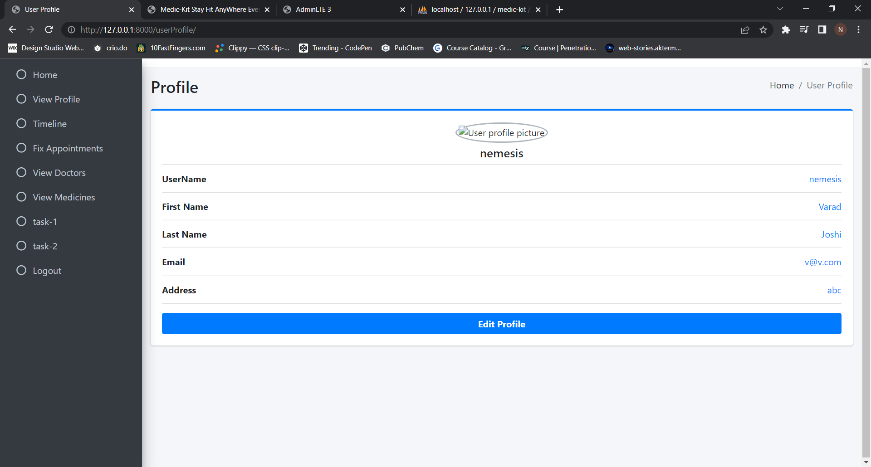

H) Timeline(user)

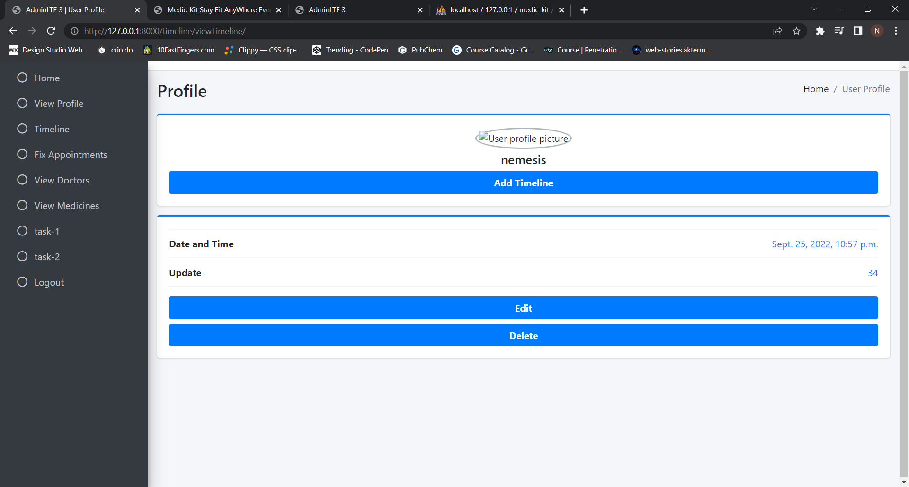

4) Admin

A) View Doctor

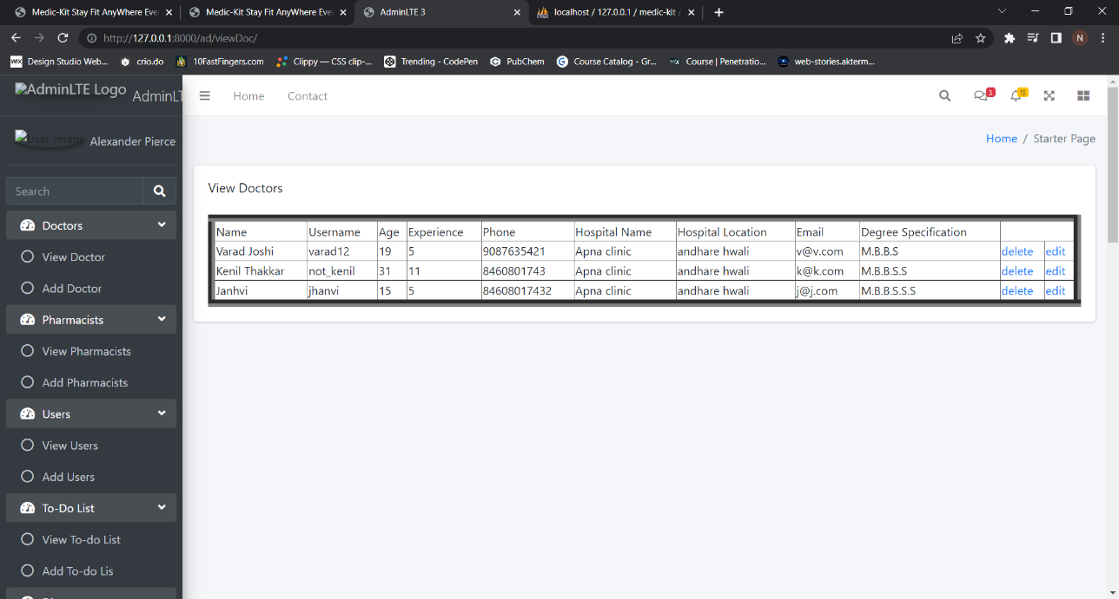

B) Add Doctors

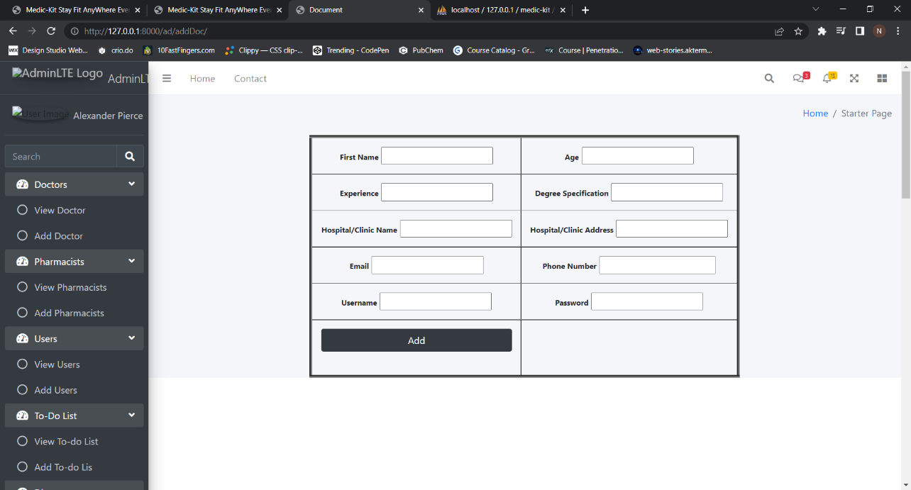

C) View Pharmacist

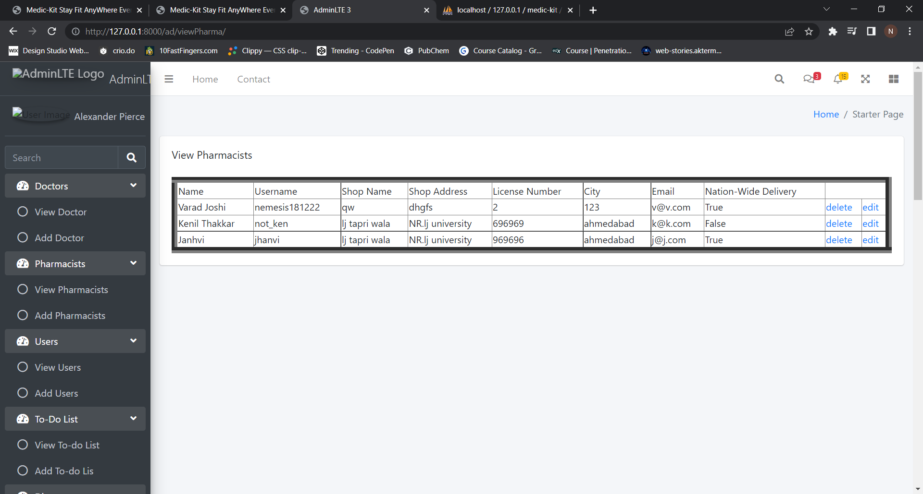

D) Add Pharmacist

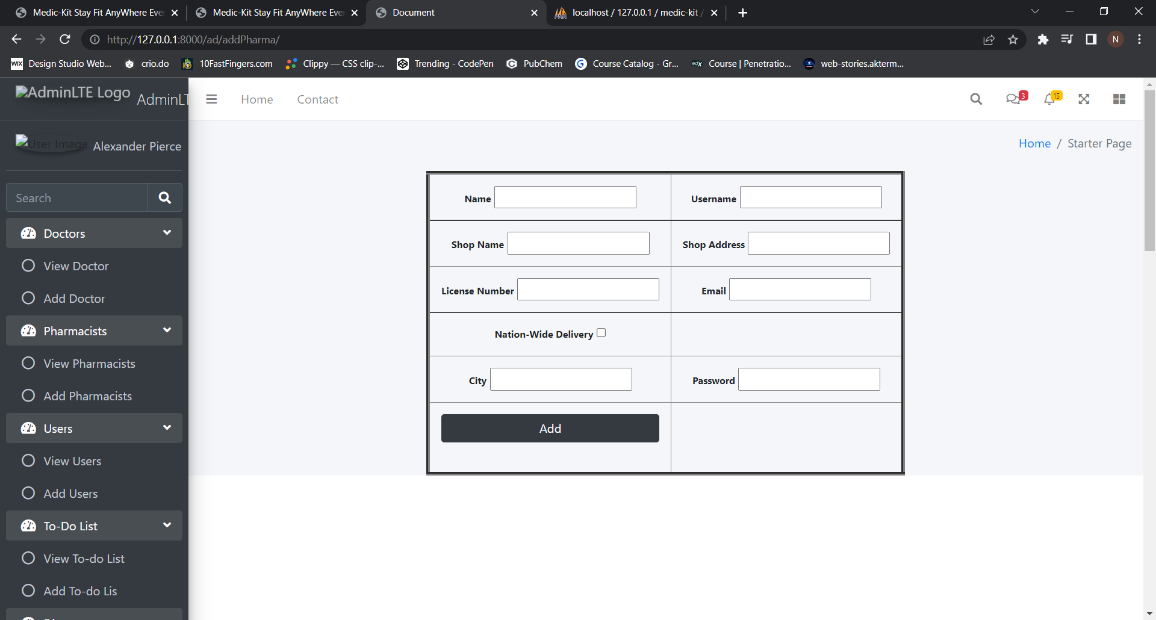

E) View Users

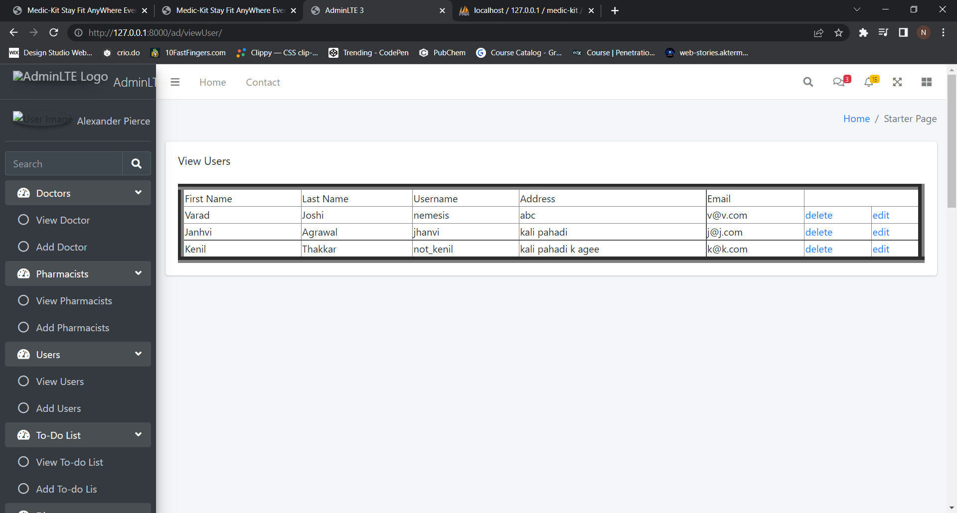

F) Add Users

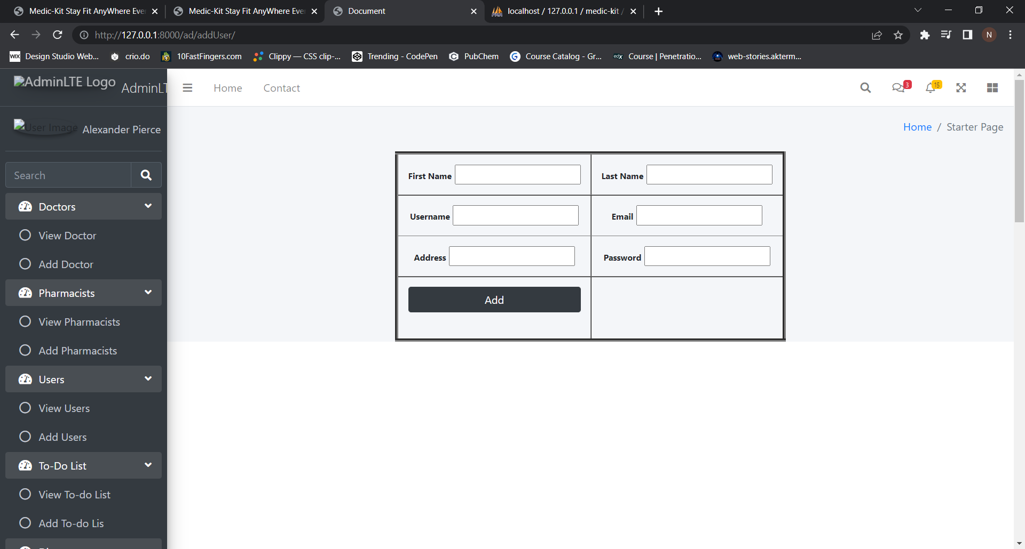

G) View To-do List

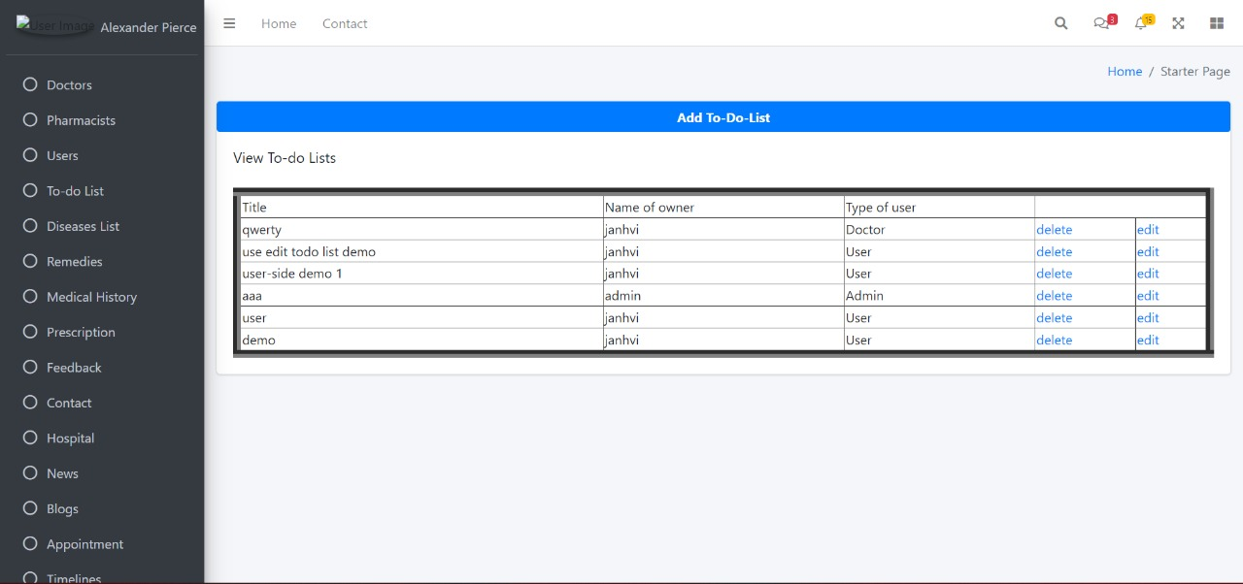

H) Add To-do list

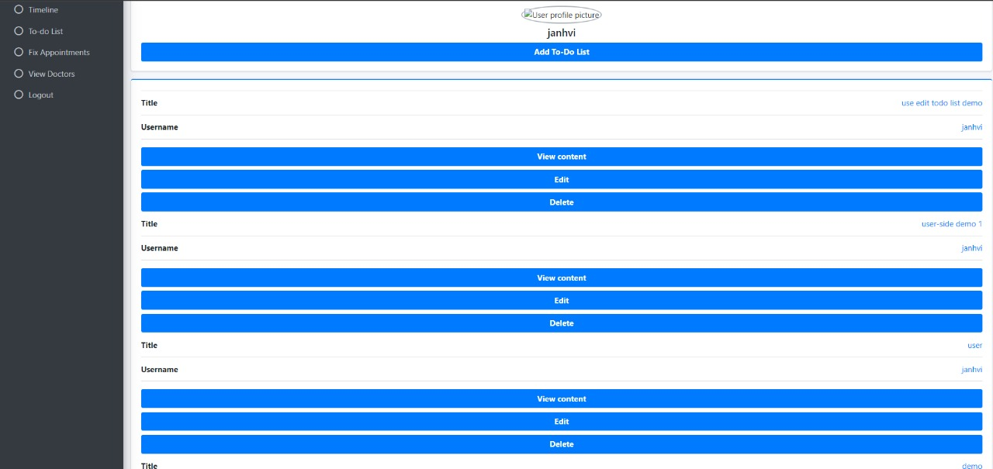

I) View Diseases

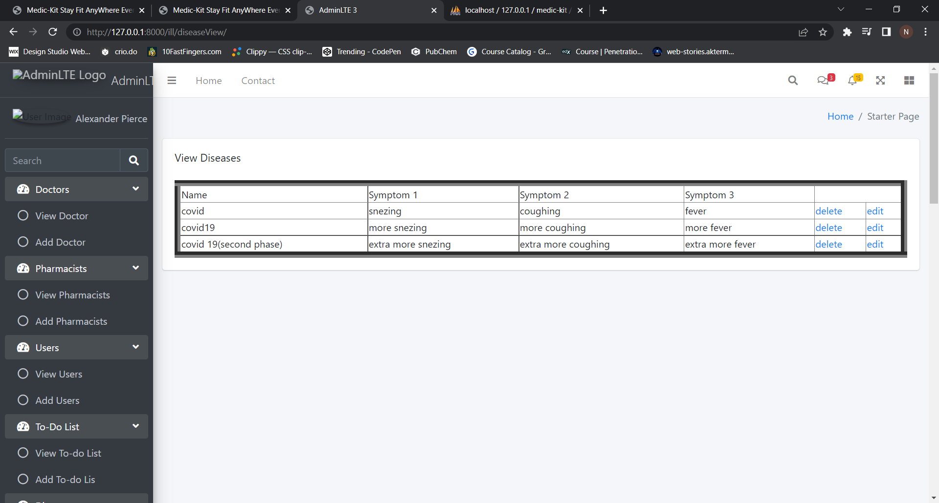

J) Add Diseases

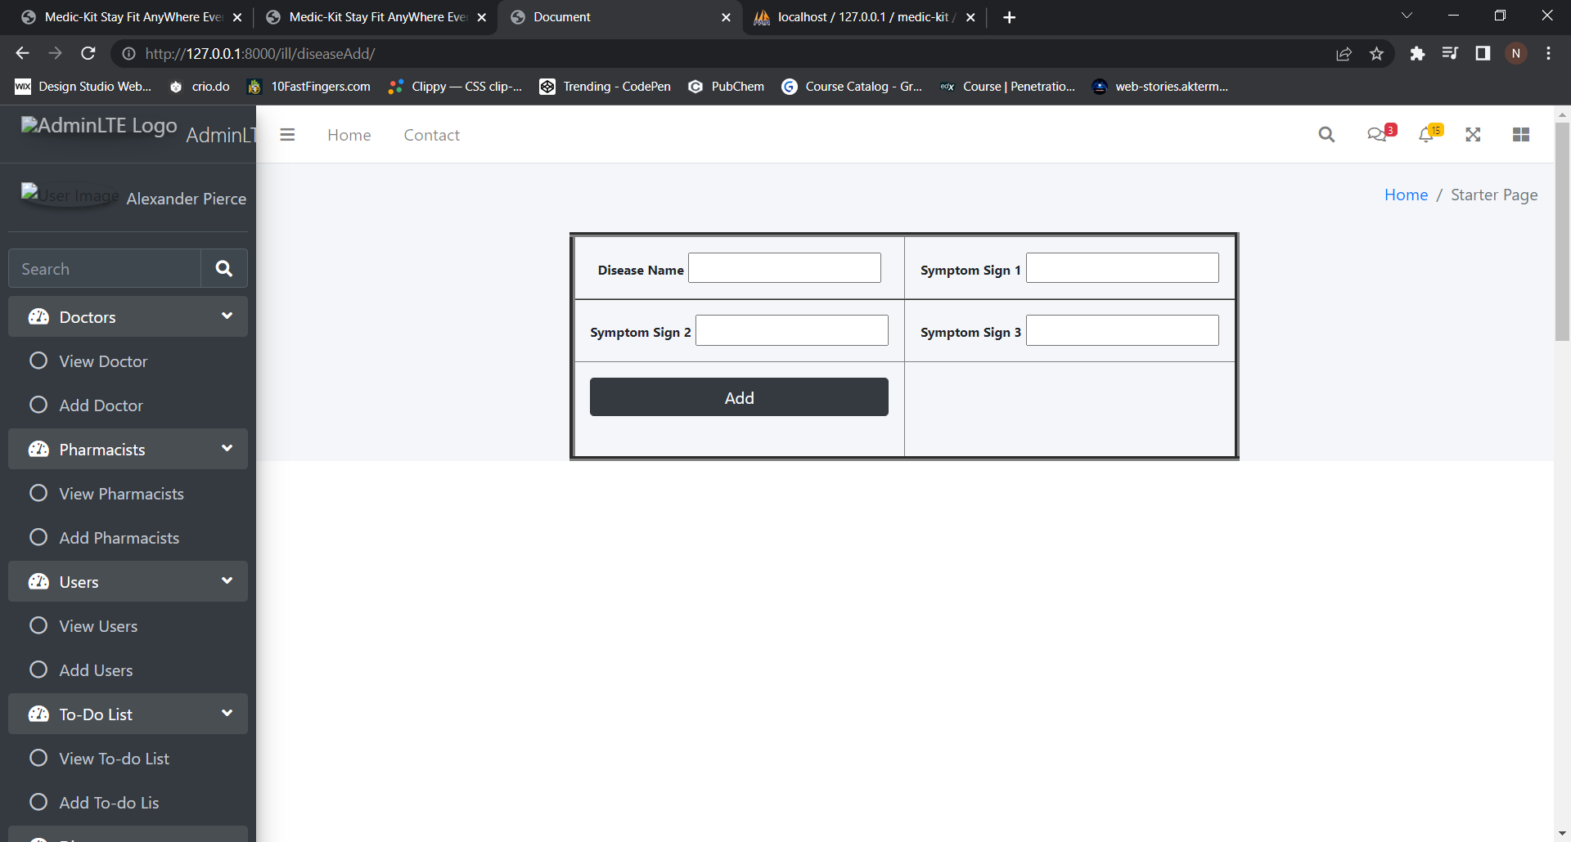

K) View Remedies

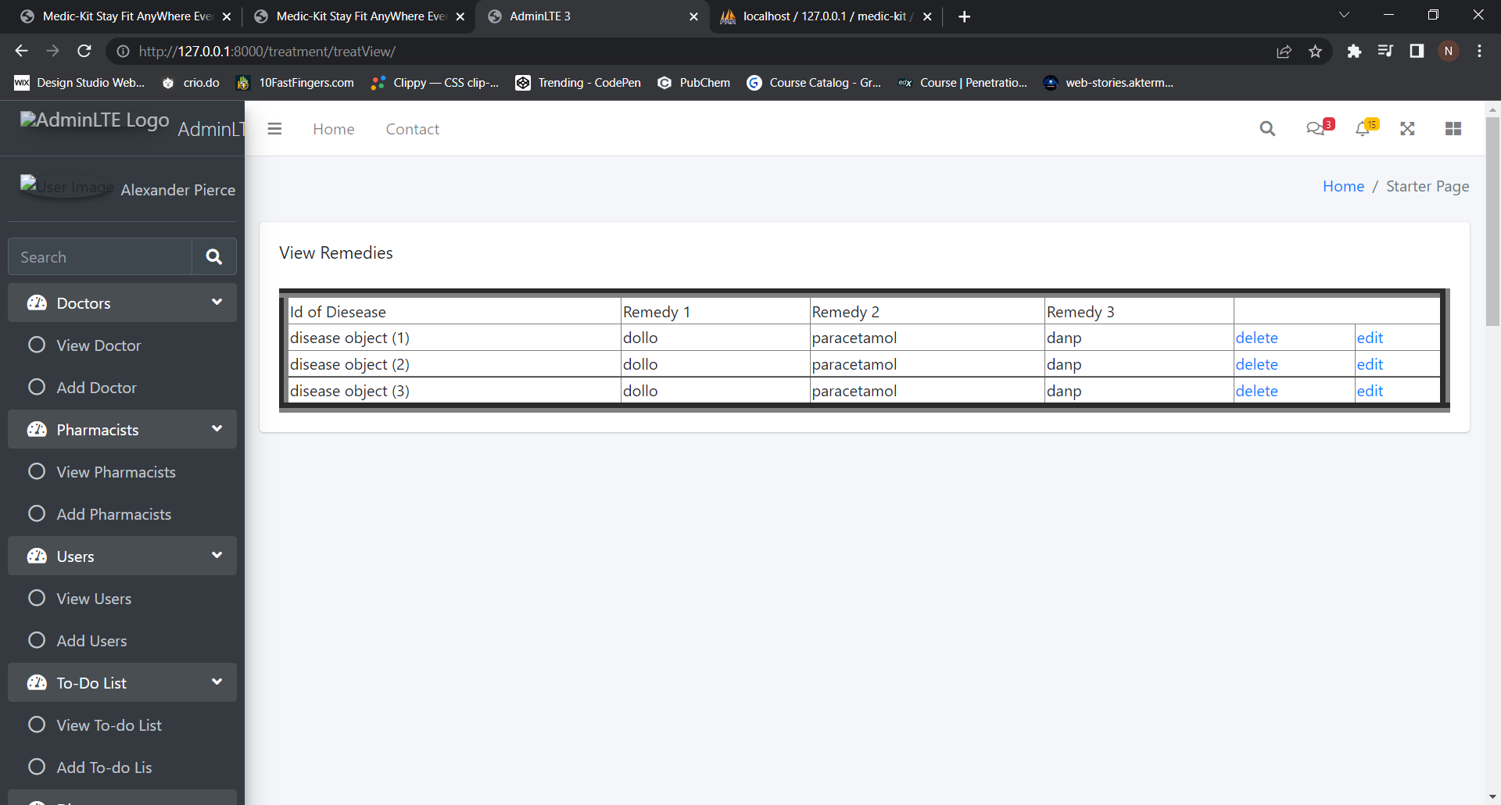

L) Add Remedies

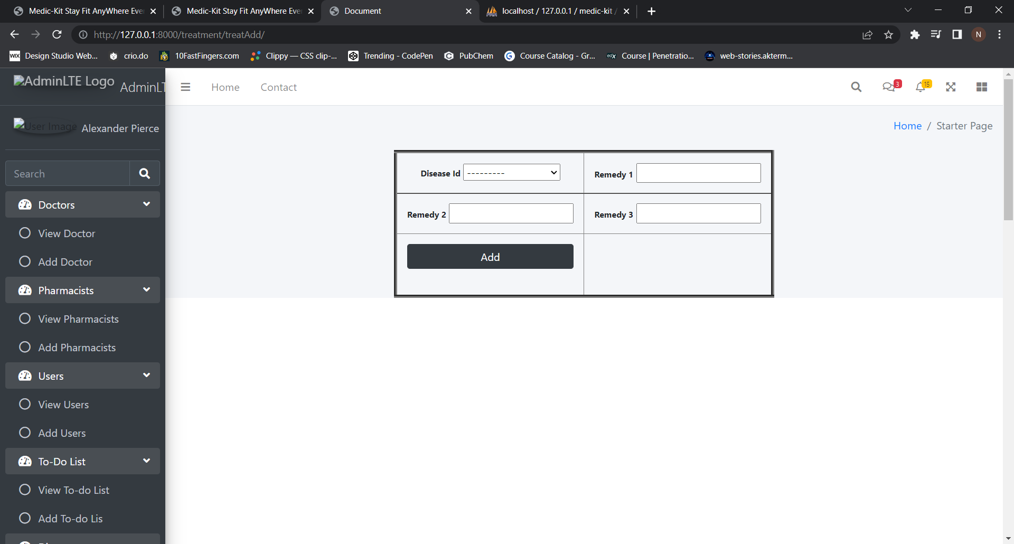

M) View Medical History

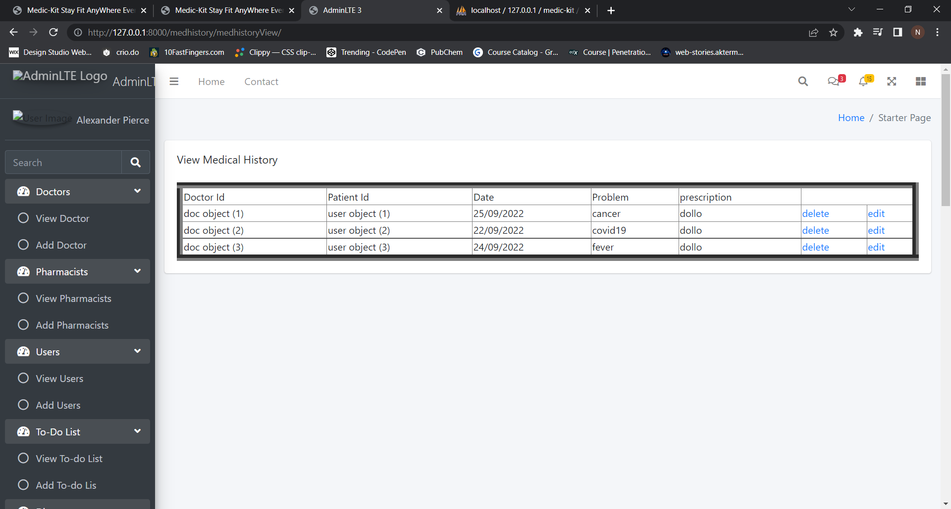

N) Add Medical History

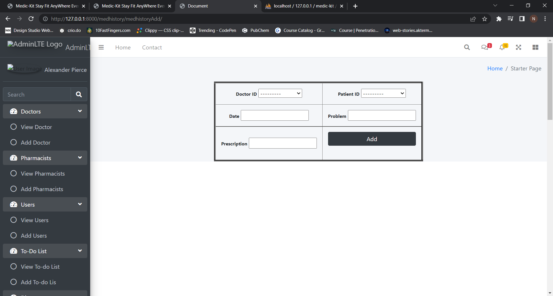

O) View Prescription

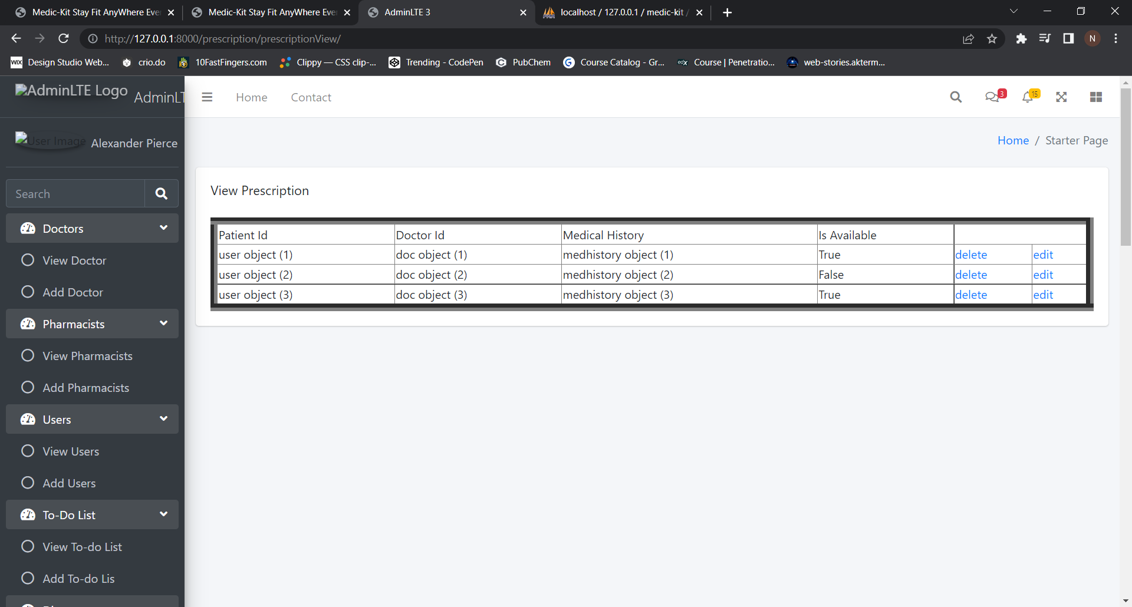

P) Add Prescription

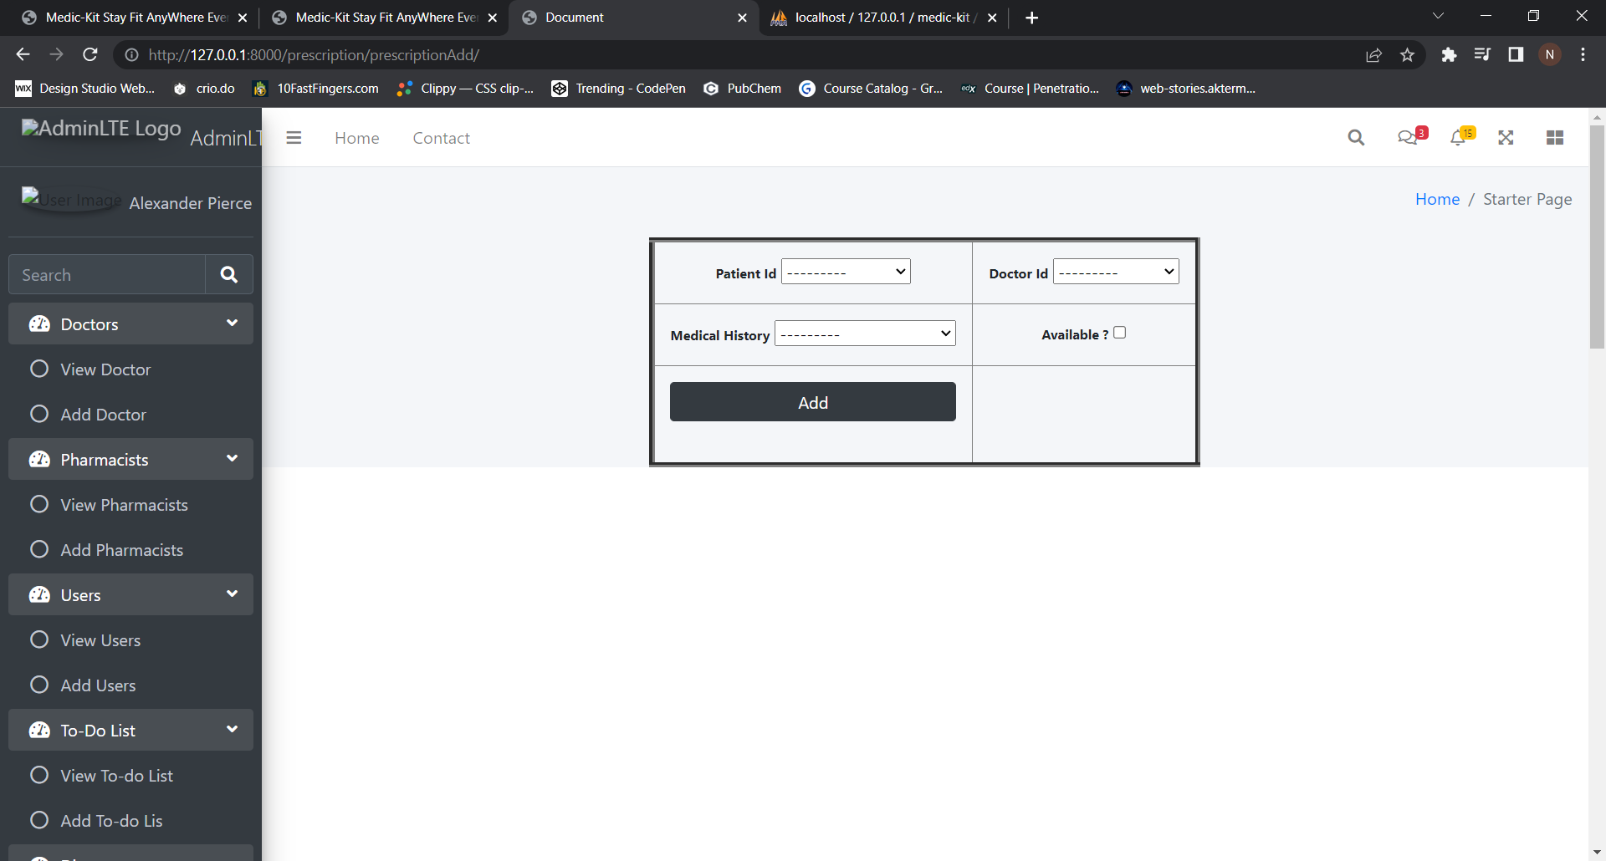

Q) View Feedback

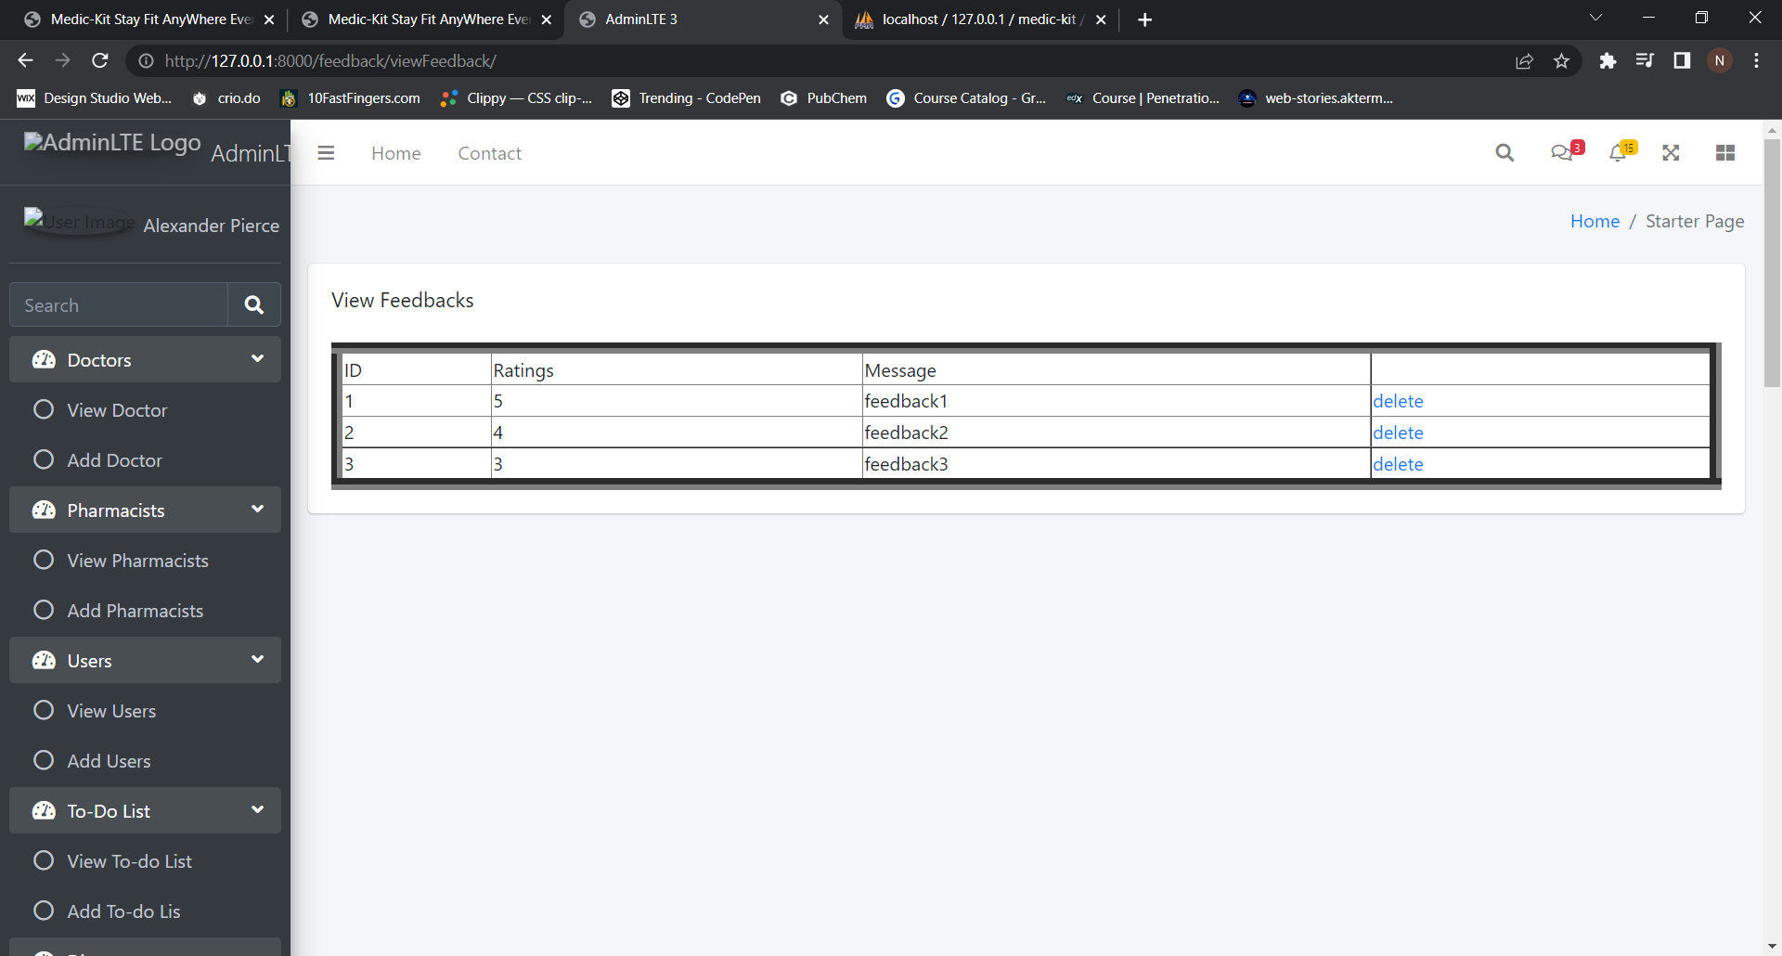

R) Add Feedback

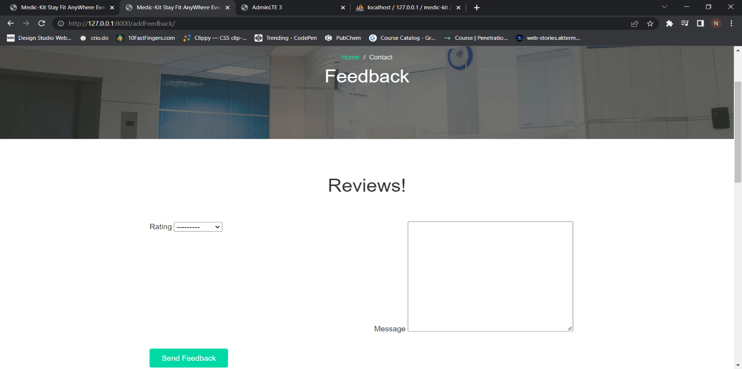

S) View Contact

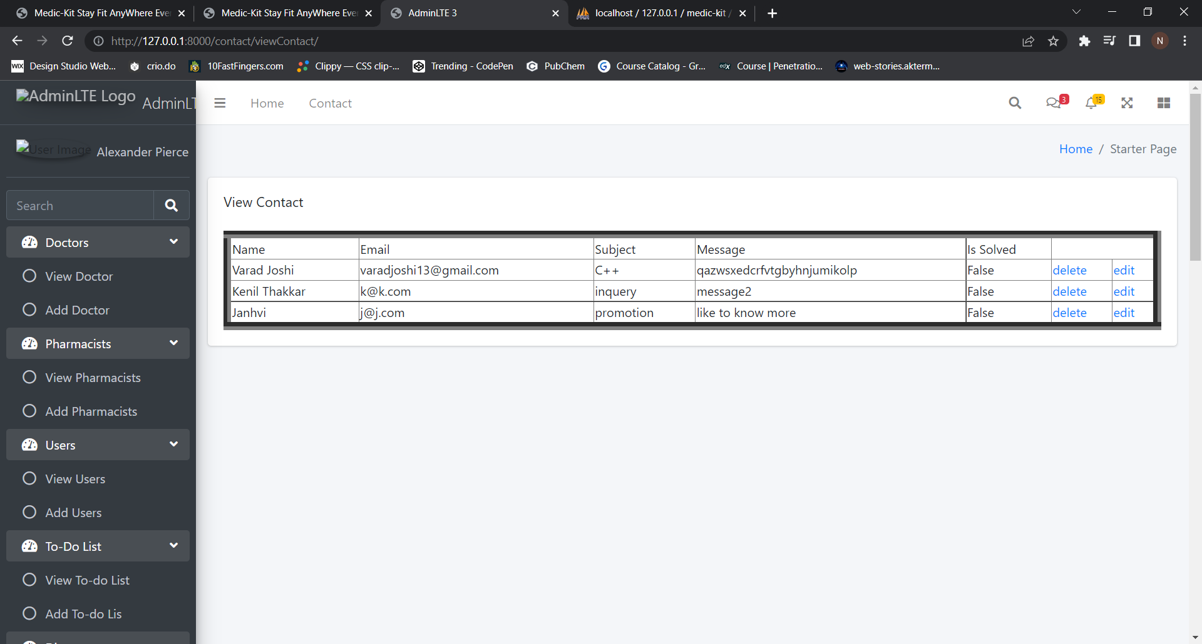

T) Add Contact

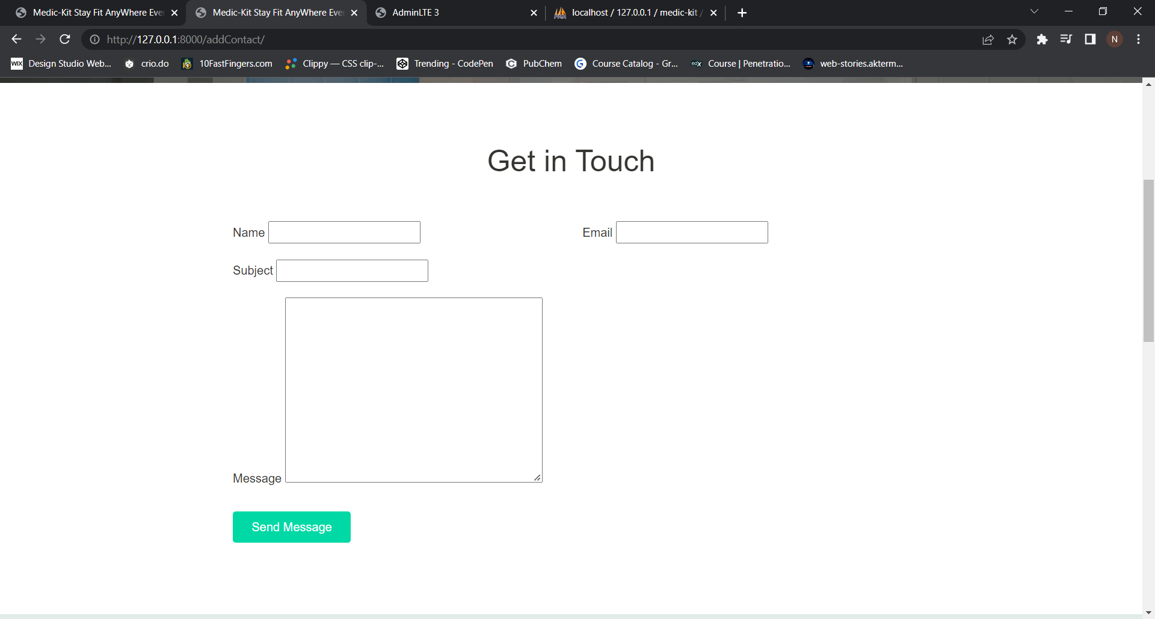

U) View Hospital

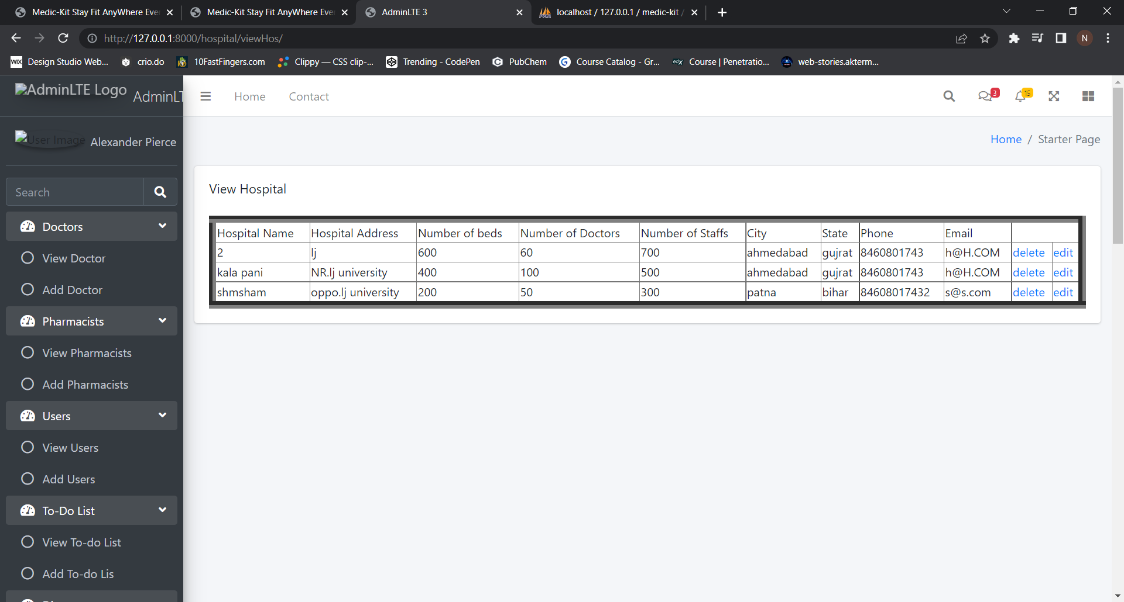

V) Add Hospital

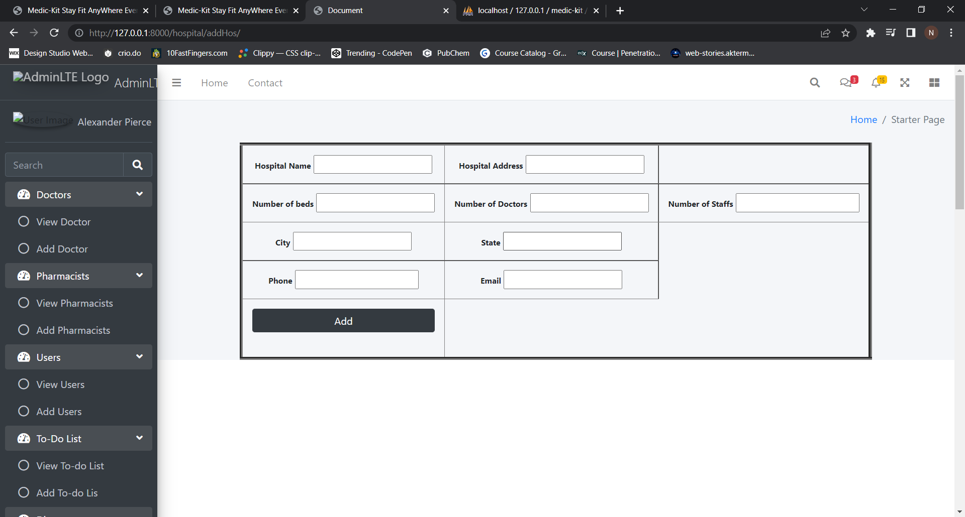

W) View News

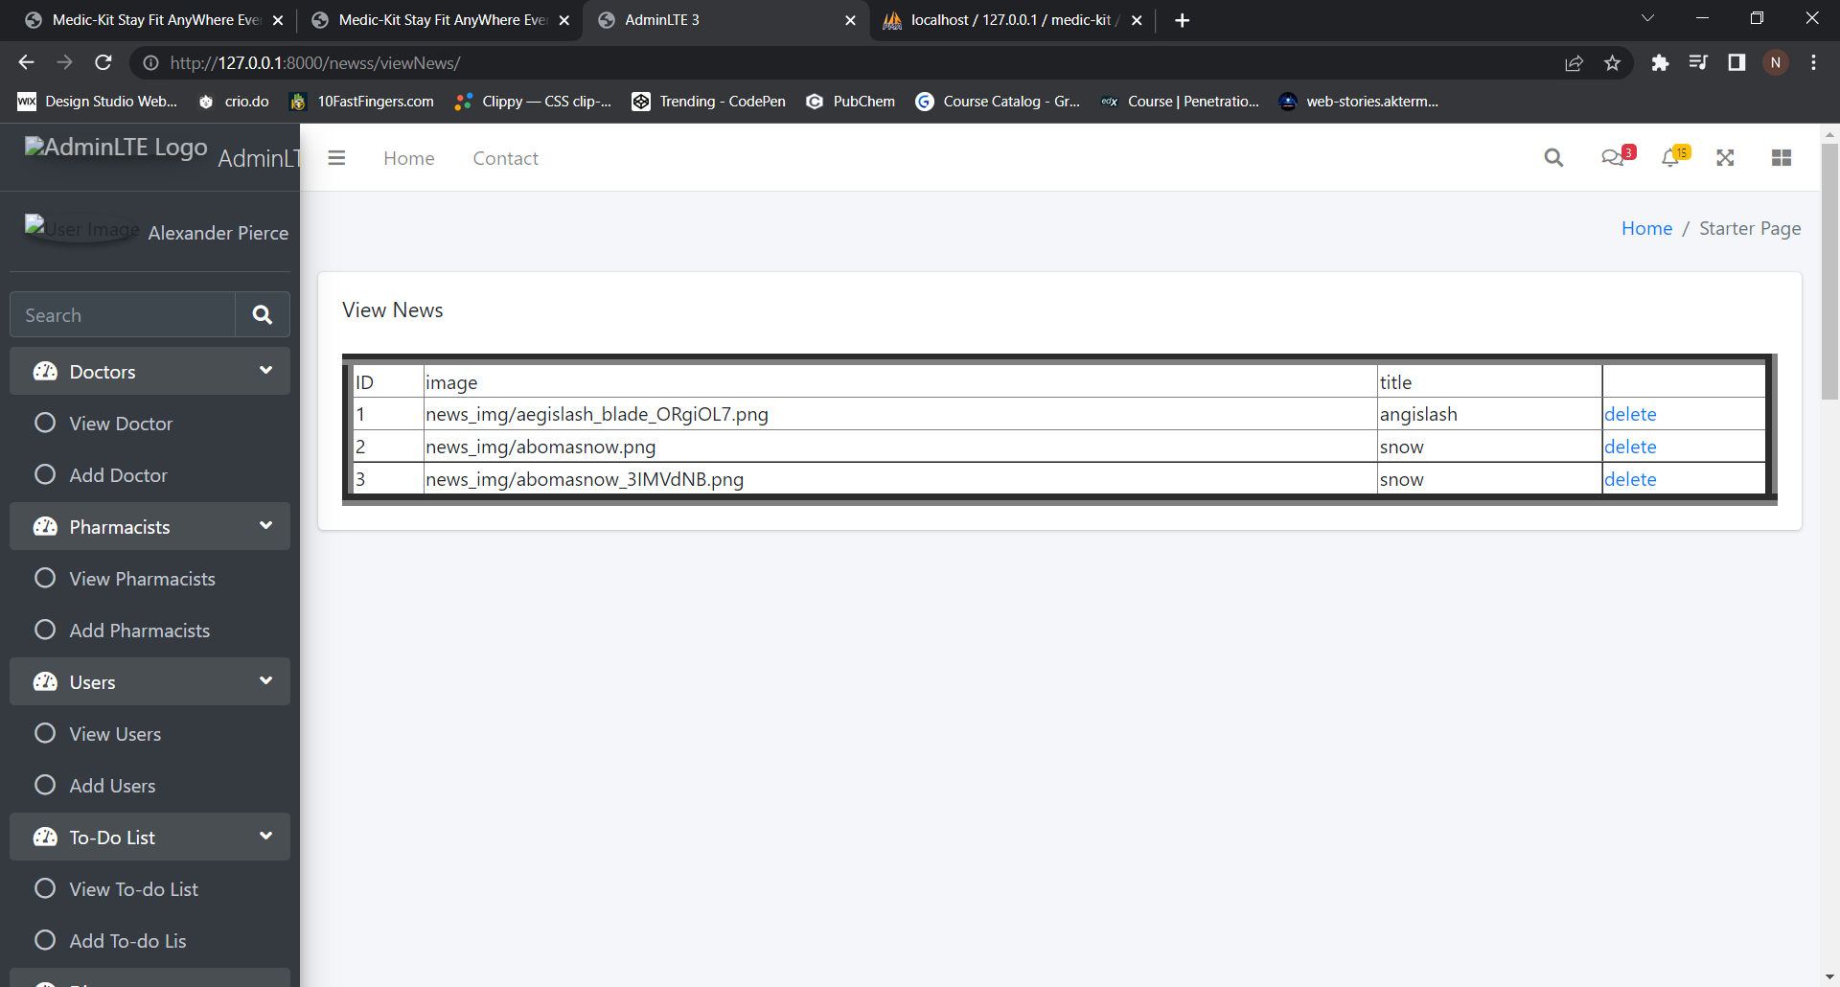

X) Add News

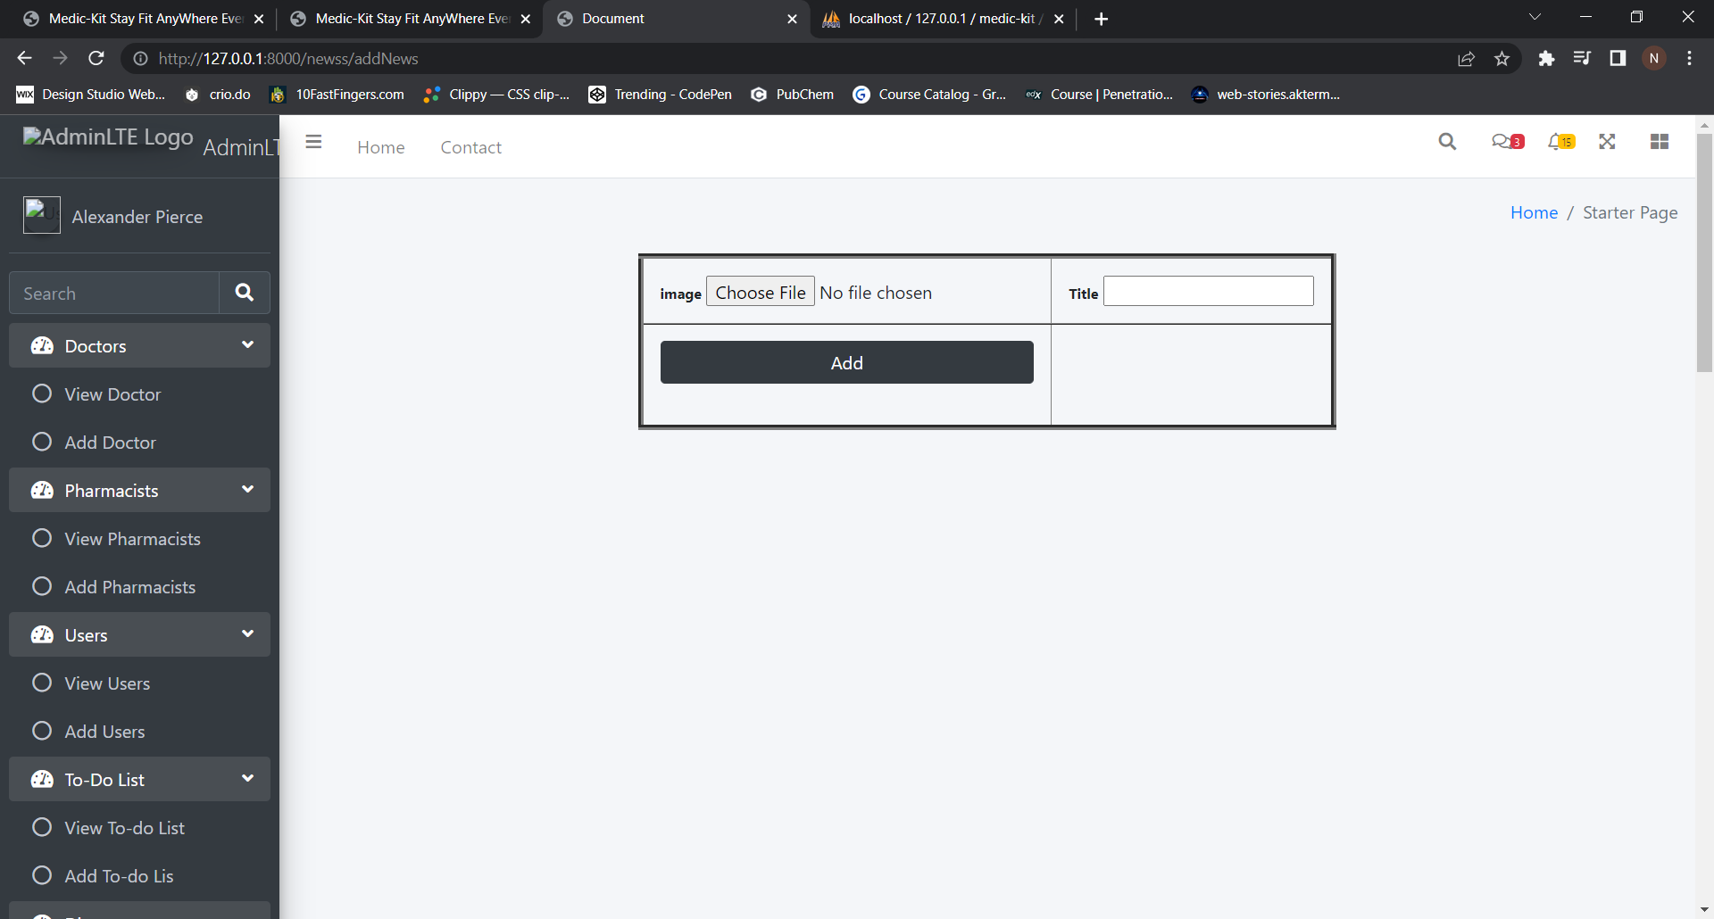

Y) View Blog

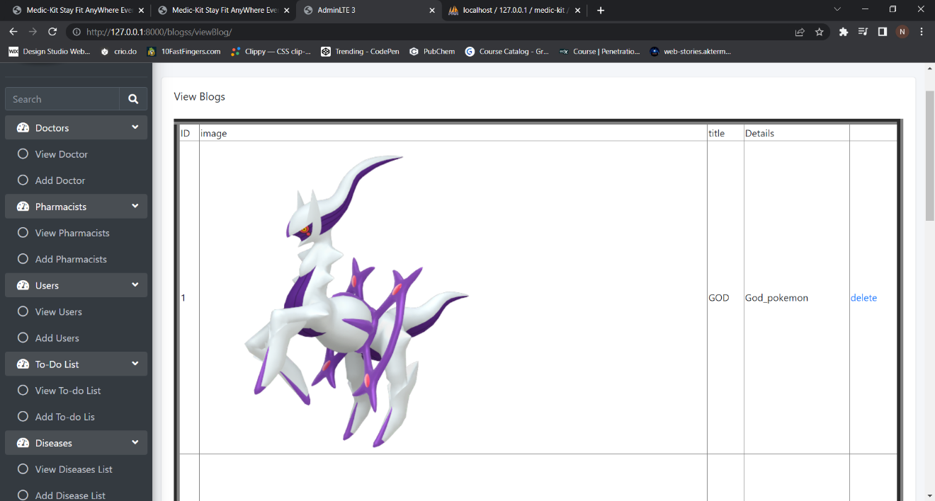

Z) Add Blog

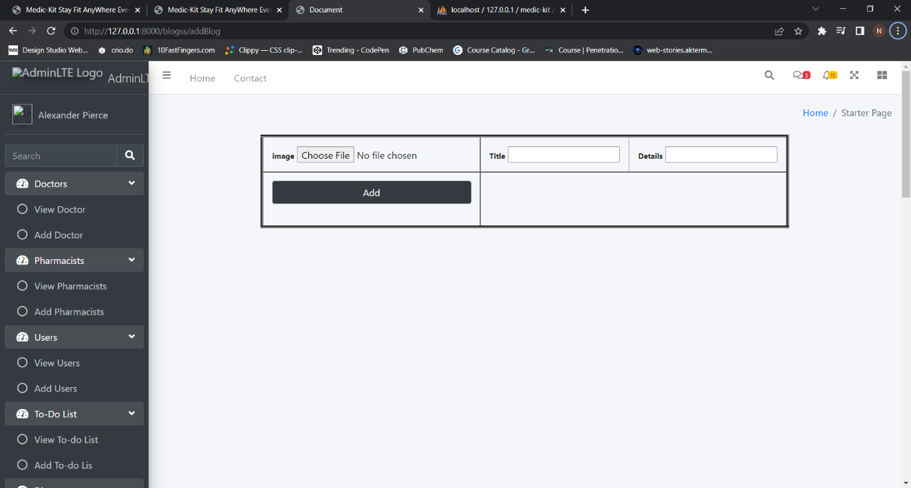

# Agile documentations

# Agile project charter

|  |  |
| --- | --- |
| **MISSION** | To provide one step solution to user’s, doctor’s and pharmacists day to day problems, and help them find optimal, budget friendly and reliable solution |
| **VISION** | To get in touch with hospitals, pharmacists and doctors all over the nation and encourage users to use the website with utmost trust. |
| **SCOPE** | The scope of the project includes the entire health industry (starting with patients to drug stores and doctors-either from hospitals or their own clinics) at national as well as international levels.  It is expandable to drug manufacturing and more. |

# Agile project plan

|  |  |  |  |  |
| --- | --- | --- | --- | --- |
| SR.NO. | DATE | MODULE | AUTHOR | STATUS |
| 1 | 30-08-2022 | Basic project | Janhvi | Done |
| 2 | 31-08-2022 | Demo project (As done in class), To-do basics | Janhvi | Done |
| 4 | 31-08-2022 | Login; Login updated | Kenil | Done |
| 5 | 01-09-2022 | Login done, User registration | Janhvi | Done |
| 7 | 02-09-2022 | Admin side | Janhvi | Done |
| 8 | 02-09-2022 | Admin side: doctor crud done | Janhvi | Done |
| 9 | 02-09-2022 | Admin side: Pharma | Kenil | Done |
| 10 | 03-09-2022 | To-do list main | Janhvi | Done |
| 11 | 03-09-2022 | Template setup | Varad | Done |
| 12 | 03-09-2022 | Disease Module | Varad | Done |
| 13 | 04-09-2022 | Contact us and feedback | Janhvi | Done |
| 14 | 04-09-2022 | Disease and Medical History | Kenil | Done |
| 15 | 04-09-2022 | Image Upload | Varad | Done |
| 16 | 04-09-2022 | News; Blogs | Varad | Done |
| 17 | 04-09-2022 | Hospital Crud | Janhvi | Done |
| 18 | 05-09-2022 | Timeline | Janhvi | Done |
| 19 | 06-09-2022 | Final Template Integration | Varad | Done |
| 20 | 07-09-2022 | Treatment crud | Kenil | Done |
| 21 | 08-09-2022 | Login; Logout | Janhvi | Done |
| 22 | 09-09-2022 | Appointment (Half) | Varad | Done |
| 23 | 10-09-2022 | Appointment full | Varad | Done |
| 24 | 12-09-2022 | BMI | Janhvi | Done |
| 25 | 13-09-2022 | User side start | Janhvi | Done |
| 26 | 13-09-2022 | Prescription | Kenil | Done |
| 27 | 14-09-2022 | Appointment (User side) | Varad | Done |
| 28 | 15-09-2022 | To-do User side integration | Janhvi | Done |
| 29 | 15-09-2022 | Logger | Varad | Done |
| 30 | 15-09-2022 | Middleware | Varad | Done |
| 31 | 16-09-2022 | Logger | Kenil | Done |
| 32 | 25-09-2022 | Excel upload download | Kenil | Done |
| 33 | 25-09-2022 | Admin side changes | Janhvi | Done |
| 34 | 26-09-2022 | User side changes | Janhvi | Done |
| 35 | 26-09-2022 | Template changes (code) | Varad | Done |
| 36 | 26-09-2022 | Email | Varad | Done |
| 37 | 30-09-2022 | Admin side | Janhvi | Done |
| 38 | 30-09-2022 | User model image add | Kenil | Done |
| 39 | 01-10-2022 | Face login | Varad | Start |
| 40 | 02-10-2022 | Face login | Varad | 50% done |
| 41 | 06-10-2022 | Face login | Varad | Done |
| 42 | 06-10-2022 | User side integration | Janhvi | Done |
| 43 | 06-10-2022 | Doctor side integration | Janhvi | 50% Done |
| 44 | 08-10-2022 | Doctor side completed | Janhvi | Done |
| 45 | 09-10-2022 | Admin side final | Janhvi | Done |
| 46 | 09-10-2022 | Blogs | Varad | Done |
| 47 | 10-10-2022 | Download changes | Varad | Done |
| 48 | 13-10-2022 | Upload download changes | Kenil | Done |
| 49 | 14-10-2022 | Half final Changes | Janhvi | Done |
| 50 | 17-10-2022 | Final Changes | Varad | Done |

# Conclusion

Medic-Kit is all about the modernizing a hospital through use of technology. Computers helps in it and take over the manual system for quick and easy functioning. This System is a quite the reliable and is proven on many stages. All the basic requirements of the hospital are provided in the hospital in order to manage it perfectly and large amount of data can also be stored. It gives many facilities like searching for a particular disease, Finding out treatment for a Disease, Managing Medicines, Managing Medical History and many more. So it is an important system for modern days.

# Bibliography

**Links:**

* [**https://www.w3schools.com/django/**](https://www.w3schools.com/django/)
* [**https://www.javatpoint.com/django-tutorial**](https://www.javatpoint.com/django-tutorial)
* [**https://www.djangoproject.com/**](https://www.djangoproject.com/)
* [**https://stackoverflow.com/\**](https://stackoverflow.com/)

**Books:**

* **Django Essentials**
* **Samuel Dauzon**